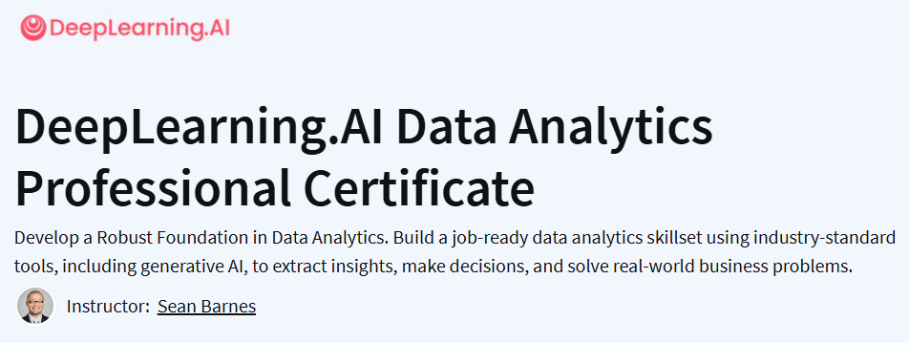**Course**

**Notes**

**Part 1**

**©️ Wasif Hossain**

**Module 1:**

* [**C1_M1.pdf**](https://community.deeplearning.ai/uploads/short-url/38bcR7HXUwyAZiRys3MVNfLuxUf.pdf)**(12.4 MB)**

**Module 2:**

* [**C1_M2.pdf**](https://community.deeplearning.ai/uploads/short-url/AewEl9Ihm8oy67sSTA6HJLlcNXC.pdf)**(5.5 MB)**

**Module 3:**

* [**C1_M3.pdf**](https://community.deeplearning.ai/uploads/short-url/mddHDY3ZsFXmarvqeudyKXW3sI7.pdf)**(6.8 MB)**

**Module 4:**

* [**C1_M4.pdf**](https://community.deeplearning.ai/uploads/short-url/xc4tG1yD1LhLrewsn3kFtZwjkav.pdf)**(8.7 MB)**